Clause 4.6 Variation to the building height development standard

The Sydney Region Growth Centres SEPP (2006) identifies the maximum building height of 12 m for the site. The DA seeks approval for a multi dwelling housing development where part of the roof area of Blocks A & E is above the maximum height plane. The applicant’s formal request is at the end of this attachment.

The proposed development seeks to vary Clause 4.3 of State Environmental Planning Policy (Sydney Region Growth Centres) 2006 which prescribes a maximum height of 12 m for the subject site. Block A has a maximum height of 12.170 m and Block E 12.250 m, representing a departure of 1.4% to 2.3% from the maximum height standard.

The following figures identify the parts of the building envelope that exceed the 12 m height limit.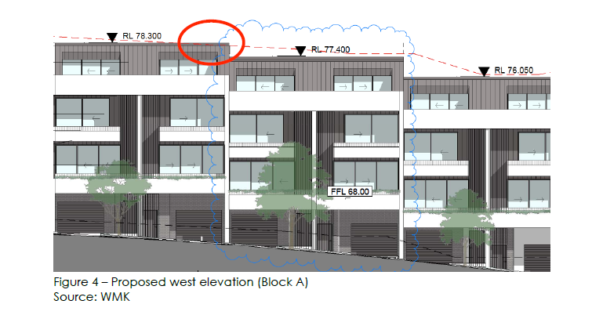

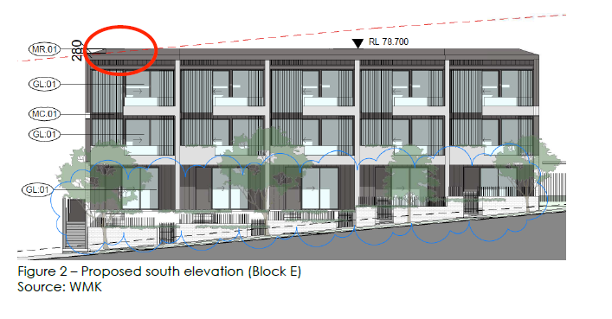

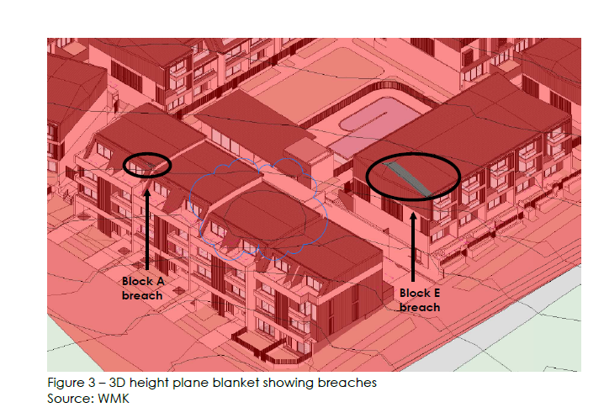

## Request under Clause 4.6 to vary from the development standard

The Applicant has submitted a request for variation to the building height development standard under Clause 4.6 of Appendix 6 Area 20 Precinct Plan under State Environmental Planning Policy (Sydney Region Growth Centres) 2006. The objective of Clause 4.6 is to provide an appropriate degree of flexibility in applying certain development standards and to achieve better outcomes for and from development by allowing flexibility in particular circumstances.

Clause 4.6 of Appendix 6 Area 20 Precinct Plan under State Environmental Planning Policy (Sydney Region Growth Centres) 2006 requires consideration of the following:

**1.** **Has the Applicant submitted a written request that seeks to justify the contravention of the development standard by demonstrating:**

**(a) that compliance with the development standard is unreasonable or unnecessary in the circumstances of the case**

The underlying objective of the height of buildings development standard is still considered relevant to the proposal. However, 100% compliance in this circumstance is considered both unreasonable and unnecessary because:

* The parts of the proposed development which exceed the height limit relate to 2 very small areas of the roof of Buildings A and E. The areas of breach are not conspicuous extensions but rather integrated components of the overall building form.
* The roof areas that exceed the height limit do not result in excessive bulk and scale and do not result in adverse shadow and amenity impacts on surrounding properties as they are minor and the overall buildings are generally below the height limit.
* The sloping nature of the site makes strict compliance difficult to achieve.
* The additional height does not result in additional yield in terms of dwellings.

Despite the height exceedance, the proposal provides a multi unit development which is compatible with the desired future character of the Area 20 Precinct.

**(b)** **that there are sufficient environmental planning grounds to justify contravening the development standard**

The proposal demonstrates sufficient environmental planning grounds to justify contravening the height of buildings development standard for the following reasons:

* The very minor extent of the breach in height would not cast any significant additional shadow.
* The variations would not result in any adverse visual impacts.
* On average, the development would be below the height limit. Only two discrete areas of the site at Blocks A and E breach the limit. The areas of the breach are not conspicuous extensions but rather integrated components of the overall building form.
* The sloping nature of the site makes it difficult to achieve strict compliance. One potential solution is to sink the buildings further into the ground. However, this strategy would adversely affect access to the dwellings, in particular sinking Block A would require additional steps down from the internal footpath to the front door and result in an undesirable sunken dwelling entry and private open space. Similarly, sinking Block E would require stepping down from the natural internal footpath and result in an undesirable sunken private open space.
* The non-complying part of Block E is limited to the sloping roof and therefore strict compliance could potentially be achieved by providing a flatter roof. However, it is considered this would result in an inferior architectural outcome, as the sloping nature of the roof provides an appropriate architectural termination of the building.
* The non-complying part of Block A facilitates the provision of high amenity private open space integrated into the roof design. Achieving strict compliance by truncating the height of the building would require removing the private open space, resulting in a loss of amenity. Additionally removing a storey at this portion of the building would disrupt the rhythm and proportions of the building and result in an abnormal building form inconsistent with the other building on the site.

It is evident that the proposal would not result in any significant environmental impacts and promotes a good design and amenity of the built environment by providing a more suitable built form than a strictly compliant development.

The Applicant’s written request seeking to justify the contravention of the development standard has adequately addressed the matters required to be demonstrated by Clause 4.6(3) of Appendix 6 Area 20 Precinct Plan under State Environmental Planning Policy (Sydney Region Growth Centres) 2006.

**2.** **The objectives of the standard are achieved notwithstanding non-compliance with the standard (Clause 4.6(4)(a)(ii))**

| **State Environmental Planning Policy (Sydney Region Growth Centres) 2006** | |
| --- | --- |
| **Objectives of Clause 4.3  ‘Height of buildings’** | **How the proposal achieves the objective** |
| To establish the maximum height of buildings on land within the Area 20 Precinct | The R3 Medium Density Residential zone within the Area 20 Precinct has an allowable height of 12 metres. The multi dwelling development has a maximum height of 12.170 m for Block A and 12.250 m for Block E which is integrated into the buildings and would provide good visual interest to the design of the buildings. |
| To minimise visual impact and protect the amenity of adjoining development and land in terms of solar access to buildings and open space | The parts of the proposed buildings exceeding 12 m do not result in additional shadow impacts as the overshadowing generated by the rooftop elements are contained within the roof area.  The overshadowing analysis indicates that the proposed building heights of Blocks A & E would not adversely impact on the surrounding visual receivers and or any adjoining open space areas. |
| To facilitate higher density development in and around commercial centres and major transport routes | The desired future development of the Area 20 Precinct anticipates the height, bulk and scale proposed in this DA, which is in close proximity to the Rouse Hill Town Centre and Tallawong Station. |

Therefore, the proposal is in the public interest because the development is consistent with the objectives of this particular development standard.

**3.** **The objectives of the zoning are achieved notwithstanding non-compliance with the standard (clause 4.6(4)(a)(ii))**

| **State Environment Planning Policy (Sydney Region Growth Centres) 2006** | |
| --- | --- |
| **Objectives of the R3 Medium Density zone** | **How the proposal achieves the objective** |
| To provide for the housing needs of the community within a medium density residential environment | The proposed development will provide housing for the community in the form of multi dwelling housing. |
| To provide a variety of housing types within a medium density residential environment | The proposed development provides a variety of dwelling sizes and types in a medium density environment. |
| To enable other land uses that provide facilities or services to meet the day to day needs of residents | Not applicable |
| To support the well-being of the community by enabling educational, recreational, community, religious and other activities where compatible with the amenity of a medium density residential environment | The proposed development provides community facilities for the residents of the proposed multi dwelling housing development, such as a communal club room and swimming pool. |

Therefore, the proposal is in the public interest because the development is consistent with the objectives for development within the R3 Medium Density zone in which this development is to be carried out.

**4.** **The concurrence of the Secretary has been obtained [Clause 4.6(4)(b)]**

This Clause 4.6 written request to vary a development standard in an Environmental Planning Instrument has been considered in accordance with Planning Circular PS 08-003. The Secretary (formerly Director-General) of the NSW Department of Planning and Environment’s concurrence is assumed by Blacktown City Council as this request is adequate, does not raise any matter of significance for State or regional environmental planning that cannot be dealt with by Council and there is no public benefit in strictly maintaining the standard in the circumstances of the proposal.

**5.** **Contravention of the development standard does not raise any matter of significance for State or regional environmental planning [Clause 4.6(5)(a)]**

There is no identified outcome which would raise any matter of significance to planning matters of State or regional significance as a result of varying the development standard as proposed under this application.

**6.** **There is no public benefit of maintaining the standard [Clause 4.6(5)(b)]**

When compared to providing a development which strictly complies with the height of buildings development standard, this application offers a public benefit because it provides for a high quality architectural design. The proposal offers improved outcomes for and from the development. Therefore, there is no public benefit in maintaining strict compliance with the development standard in this instance.

## Conclusion

The proposed development has been assessed against all matters and is considered to be satisfactory. It is considered that the likely impacts of the development have been satisfactorily addressed and that the proposal is in the public interest. The site is suitable for the proposed development subject to conditions.

## Recommendations

Based on the above assessment, the Clause 4.6 variation request is considered reasonable, well founded and meets the objectives of the R3 Medium Density Residential zone and the height of building development standard in Clause 4.3 of State Environmental Planning Policy (Sydney Region Growth Centres) 2006. Therefore, it is recommended that the Clause 4.6 variation is supported for the following reasons:

a. Adherence to the height standard is unnecessary in this instance as no adverse impacts will result from the variation to the Height of Building control.

b. The roof structures that exceed the height limit do not result in excessive bulk and scale.

c. The additional height does not result in any additional floor area.